Anaconda Installation

Process is pretty straightforward. Keep clicking next, agree to terms, select users whom you want access to Anaconda

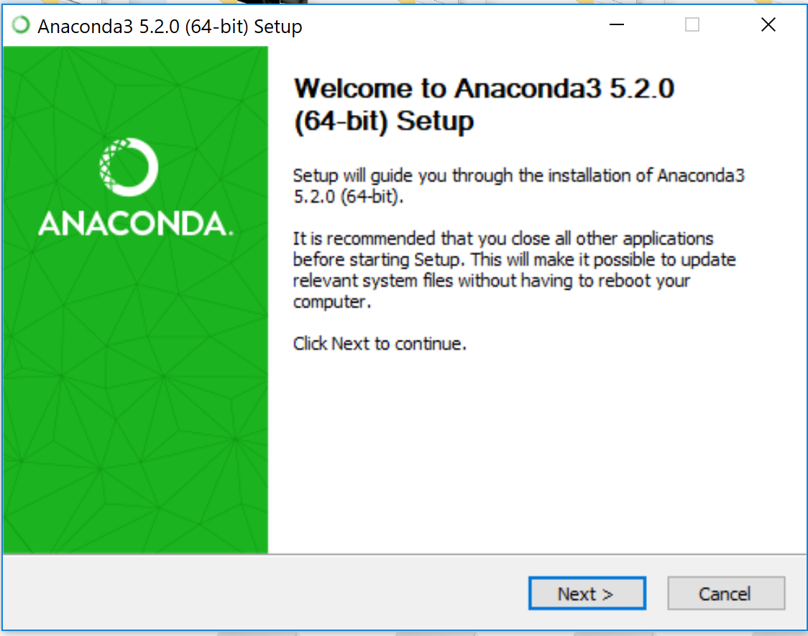

During installation do make a note of the path where anaconda is being installed

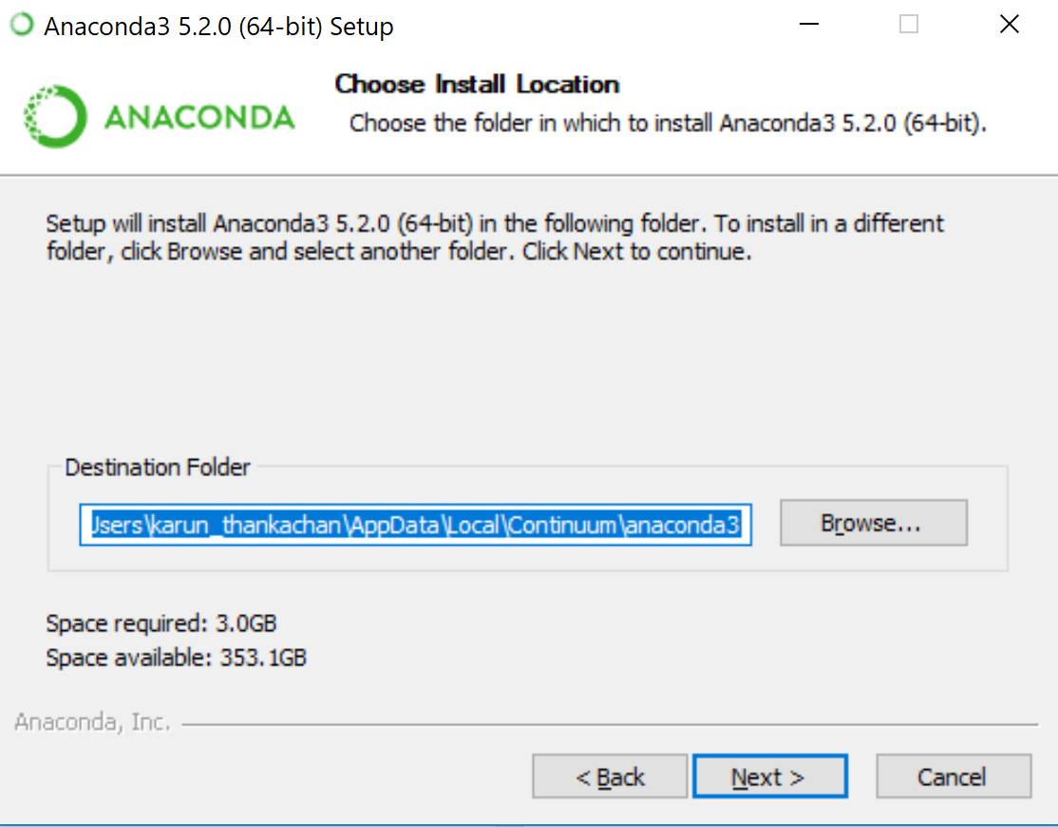

Example : C:\Users\karun_thankachan\AppData\Local\Continuum\anaconda3

DO NOT ADD ANACONDA TO PATH VARIABLE i.e. leave the first box unchecked.

DO ADD PYTHON TO PATH VARIABLE

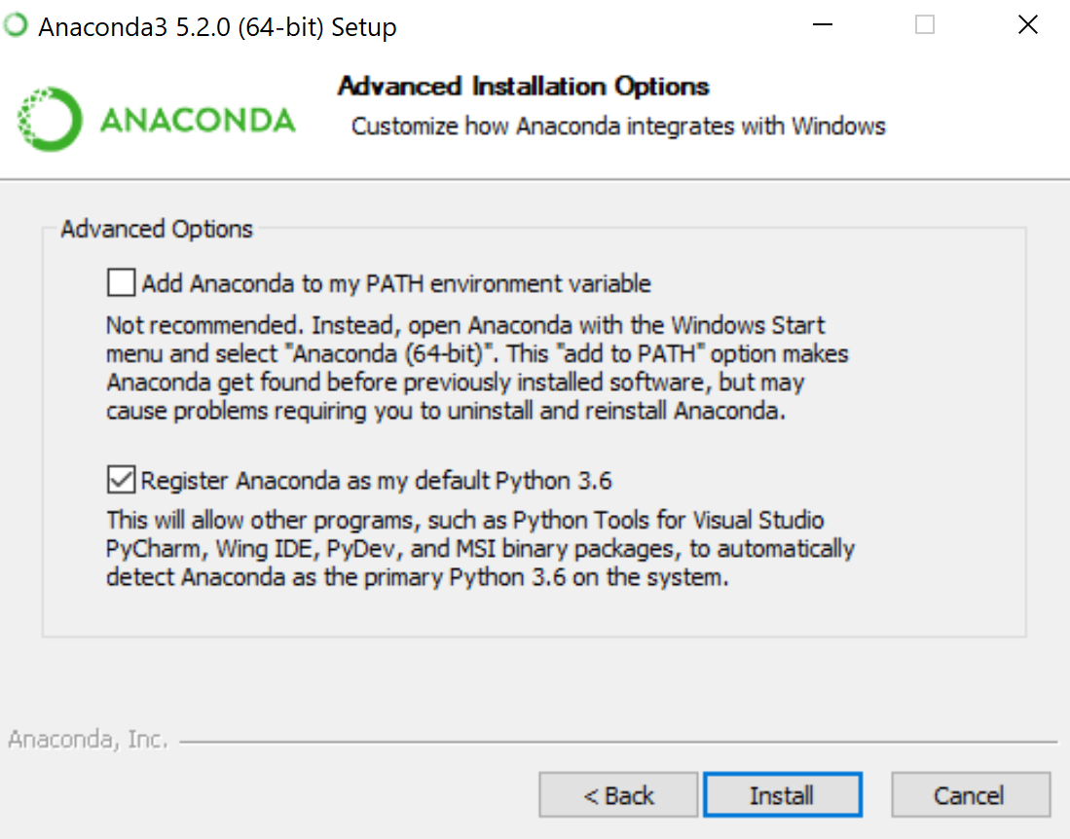

Installation time is around 8 minutes

Might see the windows command prompt pop up a few times, that’s normal

**Setting Proxy**

1. Create a .condarc file in your home i.e. C:\Users\user_name
2. Update the file with the content in .condarc in the repo
3. Open Anaconda Prompt and type

conda update conda

1. If all goes well you receive a meesage saying done.

If in case, you have any of the following special characters do use the percent encoding

|  |  |  |  |  |  |  |  |  |  |  |  |  |  |  |  |  |  |  |
| --- | --- | --- | --- | --- | --- | --- | --- | --- | --- | --- | --- | --- | --- | --- | --- | --- | --- | --- |
| **Reserved characters after percent-encoding** | | | | | | | | | | | | | | | | | |  |
| [!](https://en.wikipedia.org/wiki/Exclamation_mark) | [#](https://en.wikipedia.org/wiki/Number_sign) | [$](https://en.wikipedia.org/wiki/Dollar_sign) | [&](https://en.wikipedia.org/wiki/Ampersand) | ['](https://en.wikipedia.org/wiki/Apostrophe_(mark)) | [(](https://en.wikipedia.org/wiki/Parenthesis) | [)](https://en.wikipedia.org/wiki/Parenthesis) | [*](https://en.wikipedia.org/wiki/Asterisk) | [+](https://en.wikipedia.org/wiki/Plus_sign) | [,](https://en.wikipedia.org/wiki/Comma) | [/](https://en.wikipedia.org/wiki/Slash_(punctuation)) | [:](https://en.wikipedia.org/wiki/Colon_(punctuation)) | [;](https://en.wikipedia.org/wiki/Semicolon) | [=](https://en.wikipedia.org/wiki/Equal_sign) | [?](https://en.wikipedia.org/wiki/Question_mark) | [@](https://en.wikipedia.org/wiki/@) | [[](https://en.wikipedia.org/wiki/Square_bracket) | []](https://en.wikipedia.org/wiki/Square_bracket) | % |
| %21 | %23 | %24 | %26 | %27 | %28 | %29 | %2A | %2B | %2C | %2F | %3A | %3B | %3D | %3F | %40 | %5B | %5D | %25 |

Ref : <https://en.wikipedia.org/wiki/Percent-encoding#Percent-encoding_reserved_characters>

Anaconda Navigator

Search and Launch **Anaconda Navigator.** Should have JupyterLab, Jupyter Notebook, Spyder installed.

**Anaconda Navigator** is GUI for conda package and environment management. Environment make is possible to handle multiple version of packages in case you are working with different teams.

To create an environment – Select environment tab. Create New

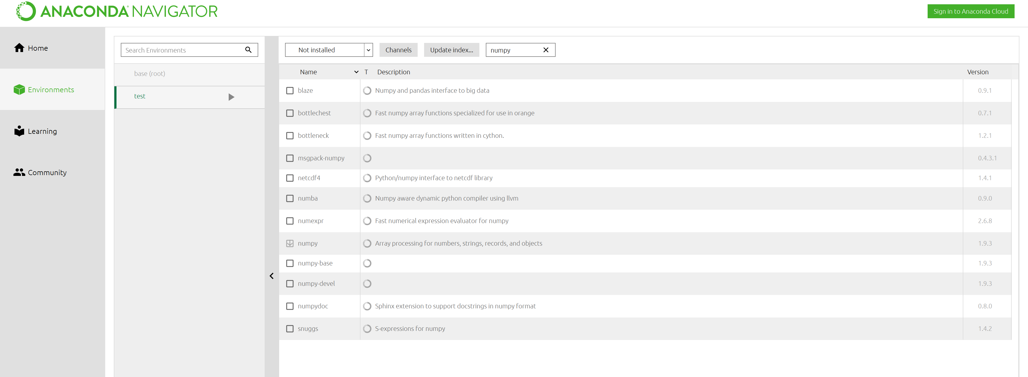

Give a name, select your version of Python

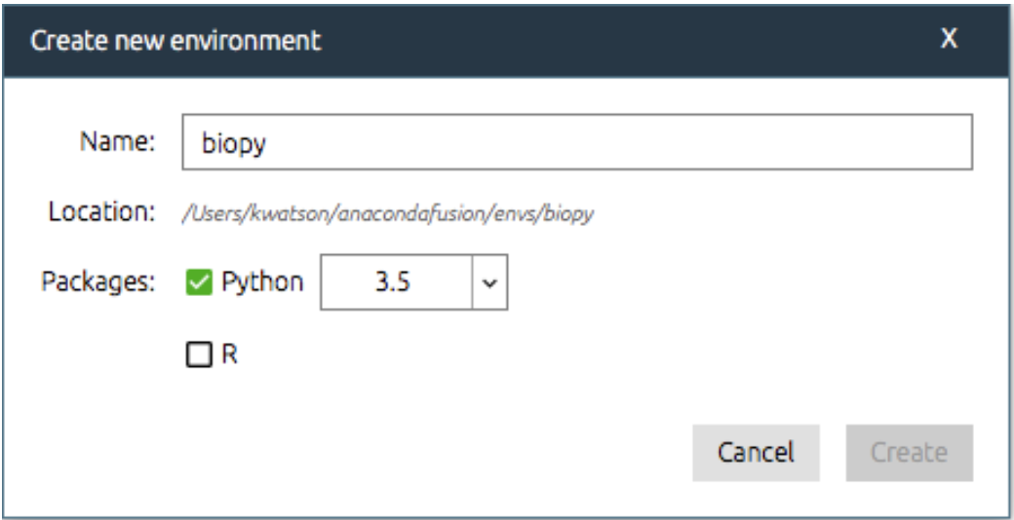

Post that whatever package you want to install, can be searched and installed in this new, clean environment

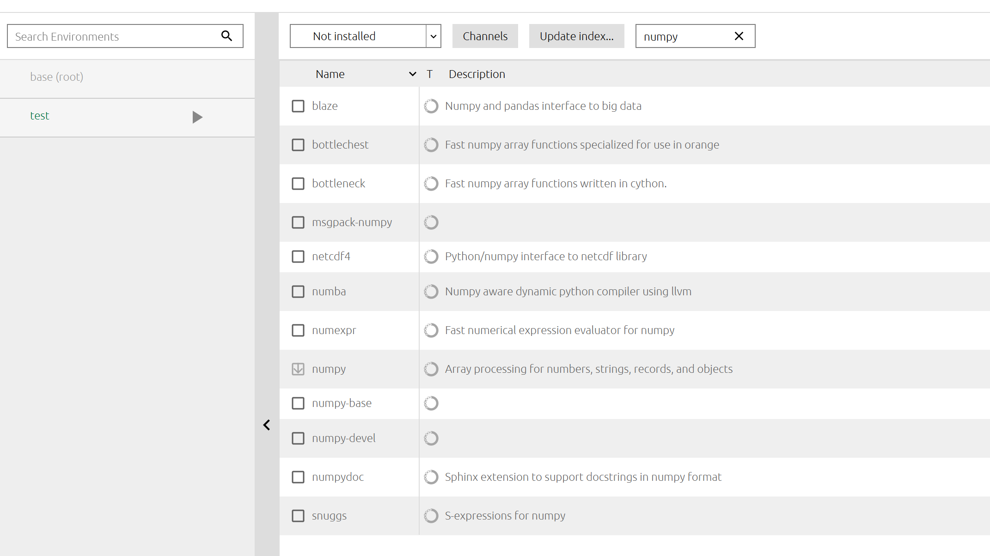

Now you have two environments and switching between them is literally as easy as clicking on them.

The same can be done through the terminal using conda

Open **Anaconda Prompt**

**To create a new environment**

conda create --name env_name

**To de active environment**

deactivate env_name

**To activate environment**

activate env_name

**To see a list of all your environments**

conda info --envs

**To install package**

conda install package_name

Ref : <https://conda.io/docs/user-guide/getting-started.html>

Spyder

An IDE tailored for data manipulation

* Help
* Variable explorer
* File explorer
* Static Code Analysis